Lecture 6, lab class 5: CFA/SEM practice questions

1. Confirmatory factor analysis
2. Is a measurement model.
3. Is a structural equation model.
4. Can hypothesise that certain factors loadings are zero.
5. All of the above.

*Correct, all of these are facts about confirmatory factor analysis, as CFA is the measurement model component, is a subset of SEM, and usually is used to constrain some factor loadings to zero.*

1. What type of factor analysis does the following diagram represent?

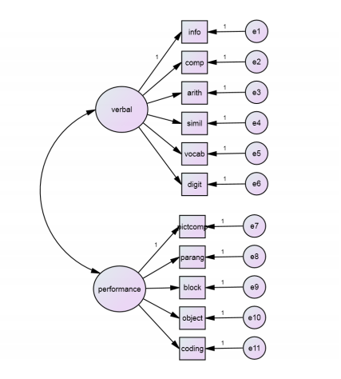

1. Confirmatory   
   *Correct, this model constrains some factor loadings to be zero, and is* *therefore confirmatory factor analysis*
2. Exploratory   
   *Incorrect, this model constrains some factor loadings to be zero, and is* *therefore confirmatory factor analysis*
3. Either confirmatory or exploratory  
   *Incorrect, this model constrains some factor loadings to be zero, and is* *therefore confirmatory factor analysis*
4. None of the above  
   *Incorrect, this model constrains some factor loadings to be zero, and is* *therefore confirmatory factor analysis*
5. What type of factor analysis does the following diagram represent?

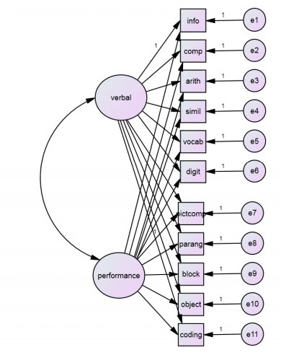

1. Confirmatory   
   *Incorrect, this model does not constrain any factor loadings or relationships*
2. Exploratory   
   *Correct, no factor loadings are held to zero, implying that this model depicts an exploratory factor analysis*
3. Multivariate regression  
   *Incorrect, this is factor analysis not multiple regression as it posits unobserved variables*
4. None of the above  
   *Incorrect, this diagram depicts exploratory factor analysis*
5. A difference between exploratory and confirmatory factor analysis is:
6. In EFA you can constrain the factors to be uncorrelated but cannot constrain particular factor loadings to be 0, whereas in CFA you can constrain some factor loadings to be 0.

*Correct, EFA does not allow you to constrain factor loadings, but CFA does*

1. In CFA you can constrain the factors to be uncorrelated but cannot constrain particular factor loadings to be 0, whereas in EFA you can constrain some factor loadings to be 0.   
   *Incorrect, you can constrain factors in confirmatory but not exploratory factor analysis, and you can constrain the factors to be uncorrelated in both*
2. EFA can restrict the number of factors whereas CFA cannot  
   *Incorrect, EFA and CFA can both constrain the number of factors*
3. CFA can restrict the number of factors whereas EFA cannot  
   *Incorrect, EFA and CFA can both constrain the number of factors*
4. In the drawing conventions for CFA
   1. An observed variable is represented by a rectangle, and an unobserved variable by an ellipse or circle.  
       *Correct, rectangles are observed variables and ellipses are unobserved variables*
   2. A factor is represented by a rectangle, and an unobserved variable by an ellipse or circle.   
      *Incorrect, factors and unobserved variables both represented by ellipses or circles*
   3. An unobserved variable is represented by a rectangle, and an observed variable by an ellipse or circle.   
      *Incorrect, rectangles are observed variables and ellipses are unobserved variables*
   4. An error is represented by a rectangle, and a factor by an ellipse or circle.  
      *Incorrect, rectangles represent observed variables*
5. To assess fit for a CFA, it is best to cite
   1. An absolute fit statistic measuring the discrepancy between model and data
   2. A comparative fit statistic measuring the model fit against a saturated or null model
   3. A fit statistic taking into account parsimony, adjusting the discrepancy for sample size and number of parameters
   4. All of the above.  
      *Correct, all of these give important and different pieces of information*
6. We fix one factor loading to 1 in order to ensure:
   1. That the model is identifiable
   2. That the scale of the factor is set.
   3. Both of the above  
      *Correct response, A and B are correct*
   4. None of the above
7. Which of the following is true?
   1. Underidentified CFA models should be avoided because they have fewer free parameters than observations, and hence prevent meaningful tests of model fit  
      *This answer is correct – many possible solutions exist that perfectly fit underidentified models, and they should be avoided*
   2. Overidentified CFA models should be avoided because they have fewer free parameters than observations, and hence prevent meaningful tests of model fit  
      *Incorrect, overidentified models are in fact preferred because they have fewer free parameters than observations, meaning that model fit can be assessed*
   3. Just-identified CFA models should be avoided because they tend to fit poorly  
      *Incorrect - just-identified* *models should not be used because they will fit the data perfectly*
   4. Underidentified CFA models should be used because they never fit the data perfectly   
      *Underidentified models should not be used because they will fit the data perfectly*
8. How many free parameters does the following model have to estimates, and how many unique variance covariance terms does the model have?

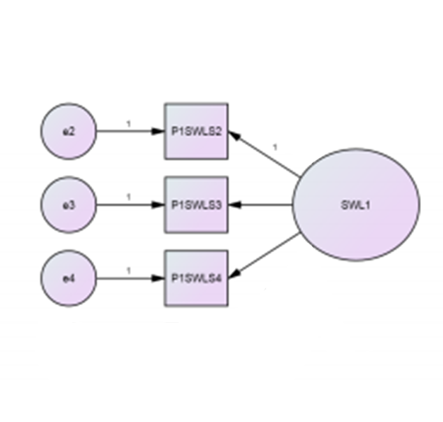

1. 2 free parameters to estimate, 3 unique variance covariance terms
2. 6 free parameters to estimate, 3 unique variance covariance terms
3. 6 free parameters to estimate, 6 unique variance covariance terms  
   *- Correct*
4. 7 free parameters to estimate, 9 unique variance covariance terms
5. The model pictured in question 9 is:
6. Underidentified   
   *Incorrect - there are the same number of unique variance covariance terms and parameters to estimate, meaning this model is just identified*
7. Just identified  
   *- Correct, there are the same number of unique variance covariance terms and parameters to estimate, meaning this model is just identified*
8. Over-identified   
   *Incorrect - there are the same number of unique variance covariance terms and parameters to estimate, meaning this model is just identified*
9. Zesty  
   *Incorrect - this is not a thing unless someone is describing citrus fruits or has run out of synonyms for “lively”*